Interactive Data Visualization with rbokeh

**rbokeh** is a visualization library – maintained by Ryan Hafen – for interactive web-based plots. It is the R interface for the python library Bokeh.

*Principles of Data Visualization for Communication*

* Self explanatory
* Informative
* Persuasive

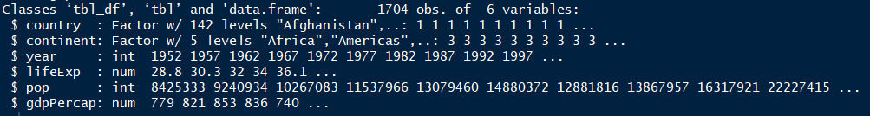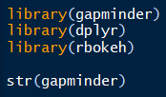**Baseline**

**Basic rbokeh plots**

*scatterplot*

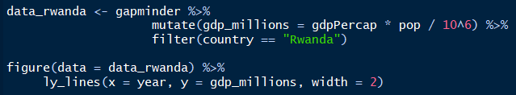

*line chart*

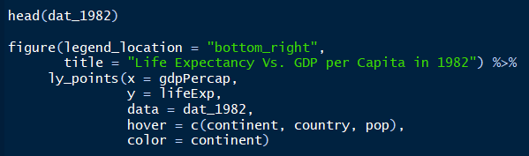**Basic rbokeh Syntax**

**layer**

**rbokeh object**

**inline calculation**

figure() %>%

ly_lines(x = year, y = lifeExp, data = data_rwanda)

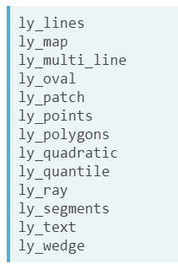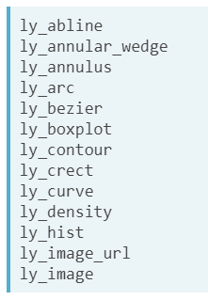

figure() %>%

 ly_lines(x = data_rwanda$year, y = data_rwanda$lifeExp)

**figure attribute**

**Basic rbokeh Multi-Layer Syntax**

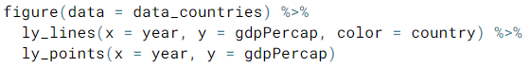

*Code shown below demonstrates tacking on an additional layer to existing rbokeh object…*

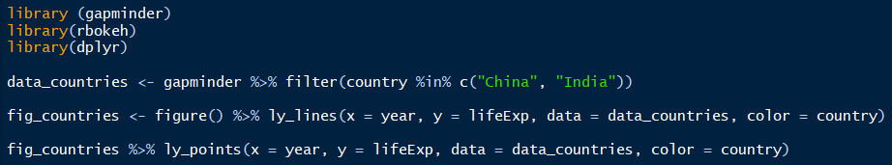

*Aesthetic Attributes*

* color
* size
* transparency
* line type
* shape

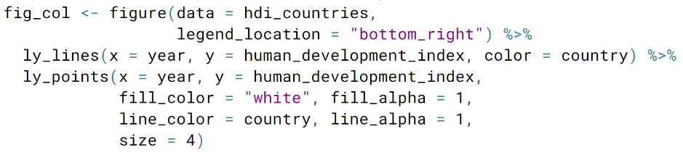

*Diverse set of aesthetics*

Overriding the default color palette (method 1)

Overriding the default color palette (method 2)

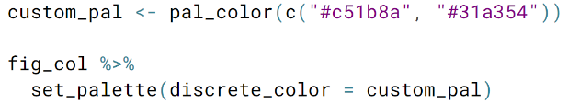

**production code snippet**

Sample of Figure Options

